Test Case: tc006_SPX_Dev5_Crear_Requisicion_Spot_Tipo_Cobro_Proyect_Urgent
Step 1 - Enter username and password and click to button Enter: Credentials Entered
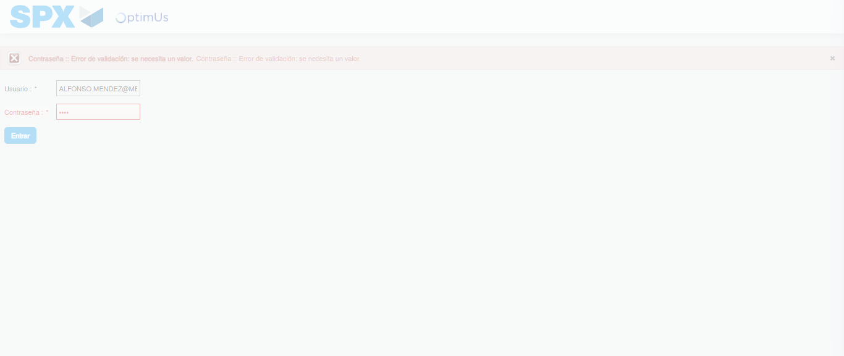Image file-name: QC_Testing-tc006_SPX_Dev5_Crear_Requisicion_Spot_Tipo_Cobro_Proyect_Urgent-1783374972254

Step 2 - Select to UEN and Access to Spot Buy Requisitions : UEN Correctly selected and Correct access
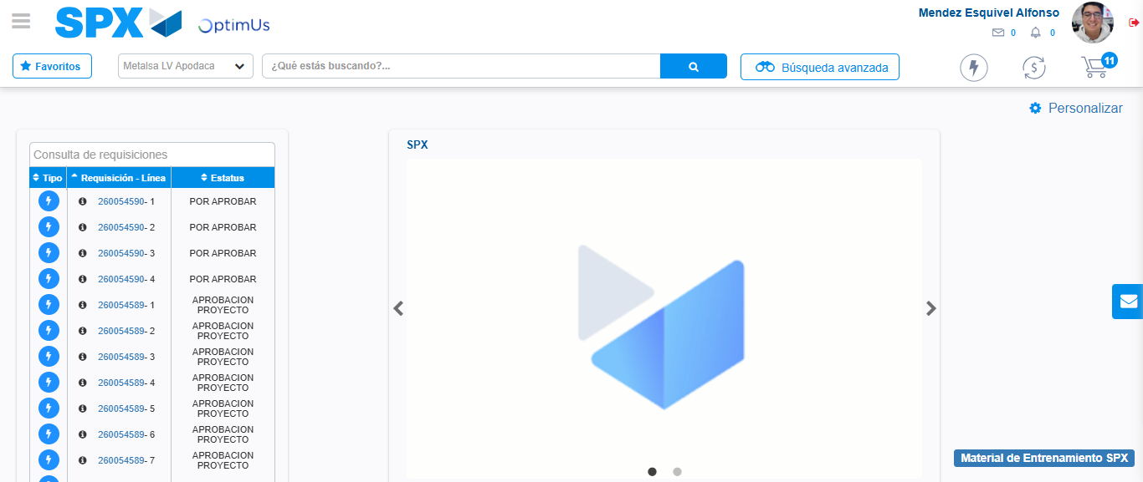Image file-name: QC_Testing-tc006_SPX_Dev5_Crear_Requisicion_Spot_Tipo_Cobro_Proyect_Urgent-1783374998296

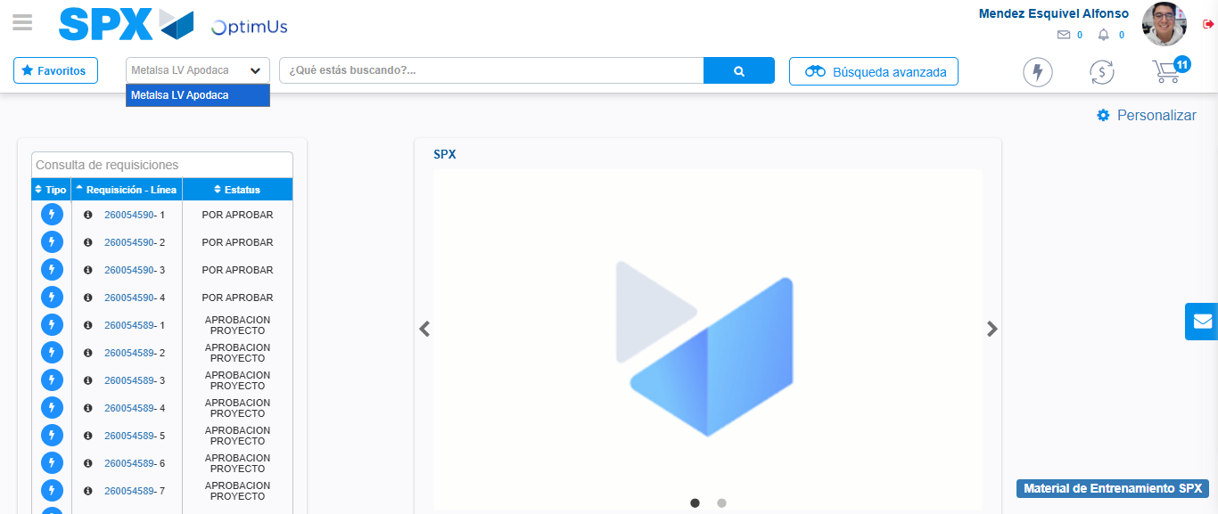Image file-name: QC_Testing-tc006_SPX_Dev5_Crear_Requisicion_Spot_Tipo_Cobro_Proyect_Urgent-1783375000795

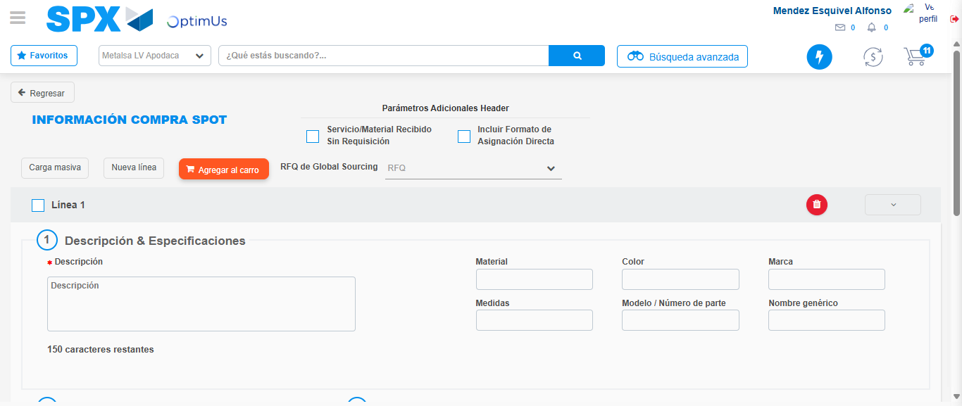Image file-name: QC_Testing-tc006_SPX_Dev5_Crear_Requisicion_Spot_Tipo_Cobro_Proyect_Urgent-1783375023187

Step 3 - Data Capture Spot Buy Requisition: Data captured correctly
Image file-name: QC_Testing-tc006_SPX_Dev5_Crear_Requisicion_Spot_Tipo_Cobro_Proyect_Urgent-1783375023421

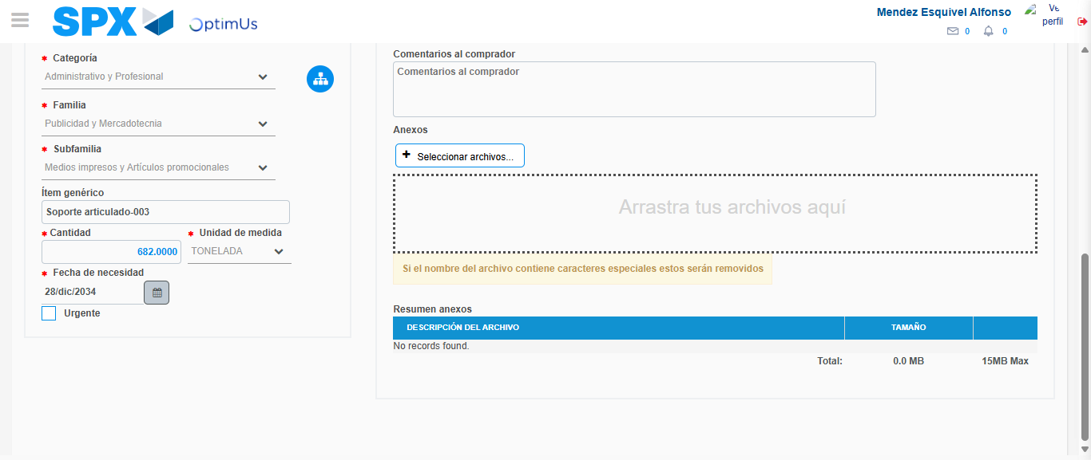Image file-name: QC_Testing-tc006_SPX_Dev5_Crear_Requisicion_Spot_Tipo_Cobro_Proyect_Urgent-1783375033406

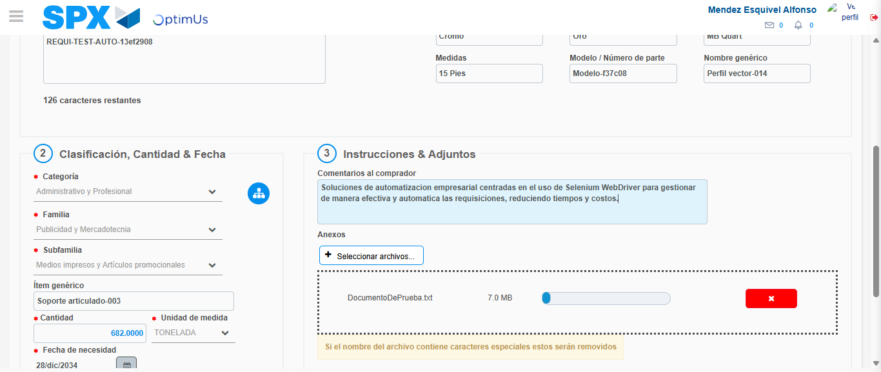Image file-name: QC_Testing-tc006_SPX_Dev5_Crear_Requisicion_Spot_Tipo_Cobro_Proyect_Urgent-1783375034106

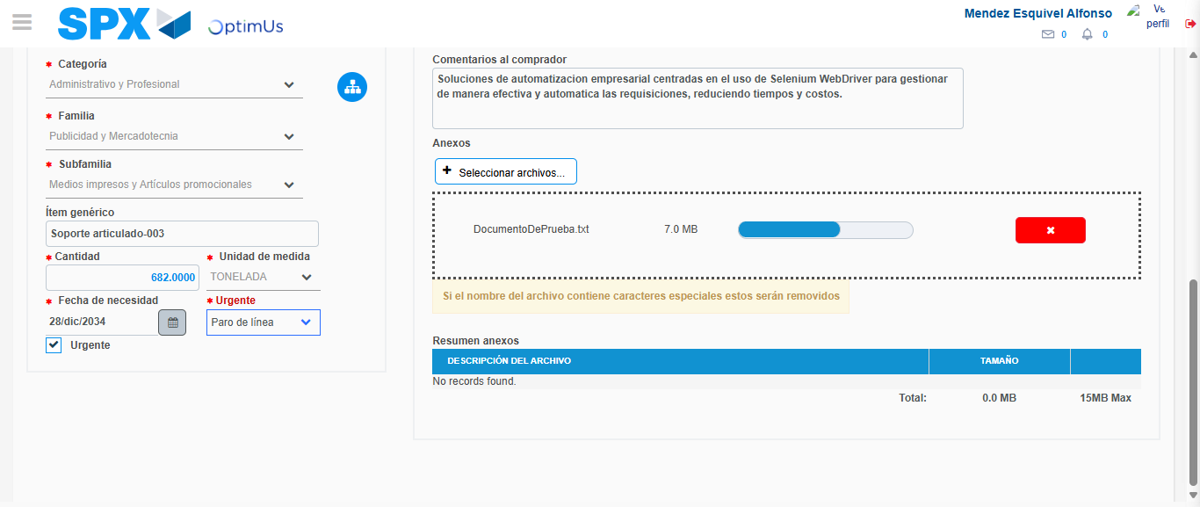Image file-name: QC_Testing-tc006_SPX_Dev5_Crear_Requisicion_Spot_Tipo_Cobro_Proyect_Urgent-1783375037672

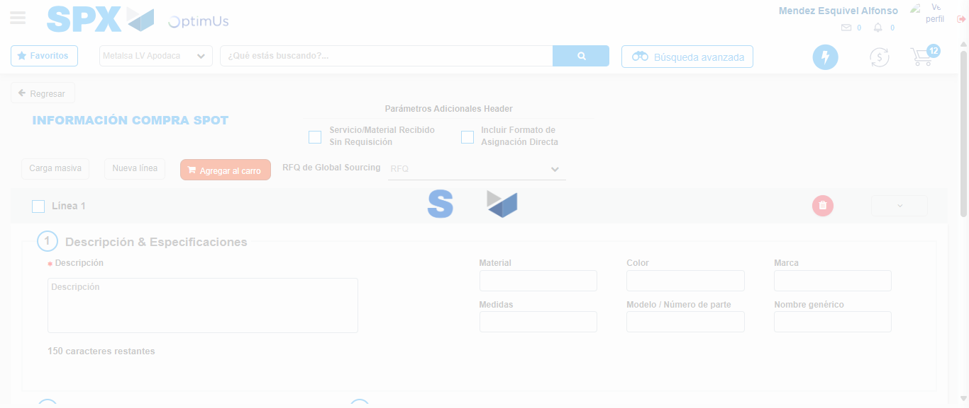Image file-name: QC_Testing-tc006_SPX_Dev5_Crear_Requisicion_Spot_Tipo_Cobro_Proyect_Urgent-1783375044583

Step 7 - Return to Main Page SPX : Return to Main Page SPX
Image file-name: QC_Testing-tc006_SPX_Dev5_Crear_Requisicion_Spot_Tipo_Cobro_Proyect_Urgent-1783374998296

Image file-name: QC_Testing-tc006_SPX_Dev5_Crear_Requisicion_Spot_Tipo_Cobro_Proyect_Urgent-1783375000795

Image file-name: QC_Testing-tc006_SPX_Dev5_Crear_Requisicion_Spot_Tipo_Cobro_Proyect_Urgent-1783375023187

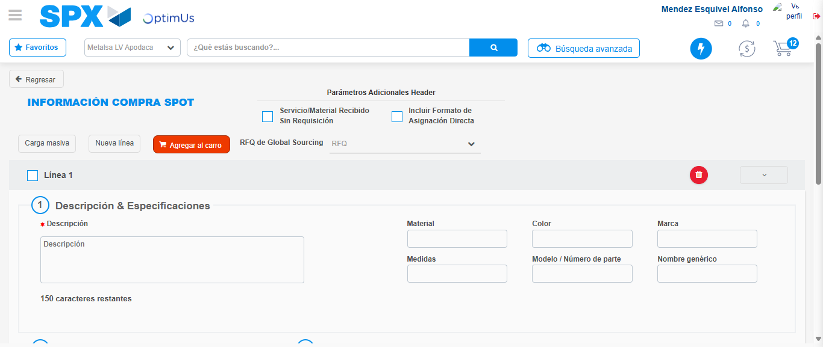Image file-name: QC_Testing-tc006_SPX_Dev5_Crear_Requisicion_Spot_Tipo_Cobro_Proyect_Urgent-1783375046814

Image file-name: QC_Testing-tc006_SPX_Dev5_Crear_Requisicion_Spot_Tipo_Cobro_Proyect_Urgent-1783375046997

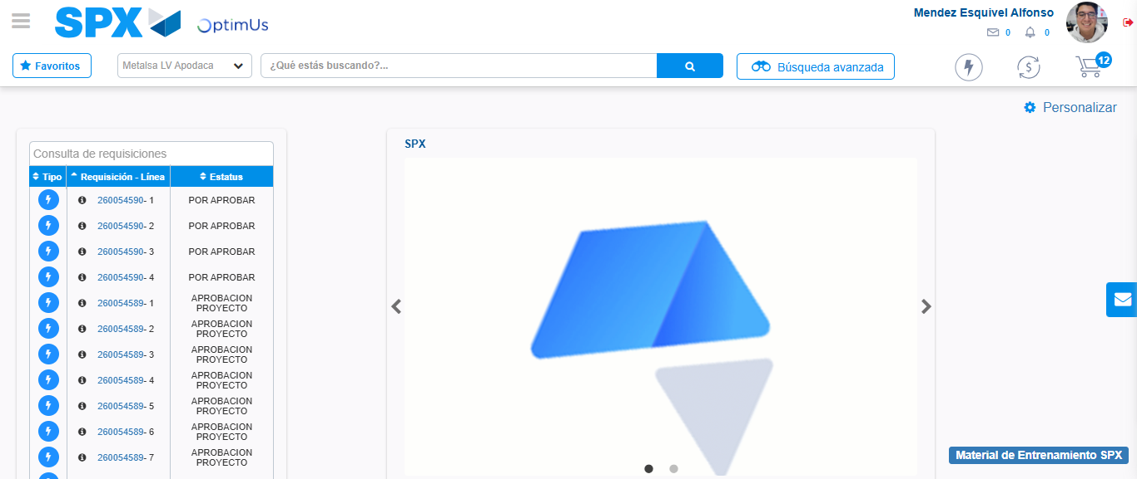Image file-name: QC_Testing-tc006_SPX_Dev5_Crear_Requisicion_Spot_Tipo_Cobro_Proyect_Urgent-1783375068014

Step 8 - Log Out : Log Out SPX
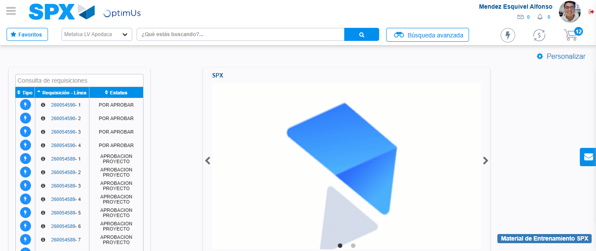Image file-name: QC_Testing-tc006_SPX_Dev5_Crear_Requisicion_Spot_Tipo_Cobro_Proyect_Urgent-1783375068262

